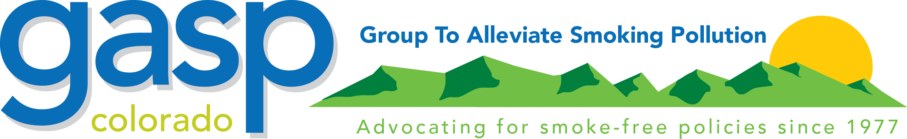
Smoking in Food Preparation Areas

Rules and Regulations Governing the Sanitation of
Smoking in Food Service Establishments in the State of Colorado
July 1, 1978
Employee Practices 3-401(b)
Employees shall not use tobacco in any form while engaged in food preparation or service, nor while in areas used for equipment or utensil washing or for food preparation. Employees shall use tobacco only in designated areas. An employee tobacco-use area shall not be designated for that purpose if the use of tobacco there may result in contamination of food, equipment, utensils, or other items needing protection.
REASON: Smoking or eating by employees anywhere but in these areas is prohibited because of the probability of contamination of food and food-contact surfaces by the employees because of these activities.
You can report a violation through tobaccofreeco.org.

GASP Note: The Colorado Clean Indoor Air Act now prohibits smoking in most public places and work places.

A Public Service of the Group to Alleviate Smoking Pollution
(GASP of Colorado) www.gaspforair.org

